September 1st 2026 The Alletto Family Chronicle Page 1 #111111111111111111111111111111111111111111111111111111
Page 1 Page 2 Page 3 Page 4


September 1st 2026 The Alletto Family Chronicle Page 1 #111111111111111111111111111111111111111111111111111111
Cousins Top to Bottom: David, Olivia and Dana (Calvacca) Schwartz and Pat and Gus Calvacca. All Enjoying the Twins Game with the Family
Move In Day VCU 2030—Niece Lisa Maher Monahan reports: Move in day for Ashley Monahan. This was the last big milestone for our family this year, but the one that I was most anxious about, the mom sending her last baby out into the world. But I did it without as many tears as I had 10 years ago when we moved Brianne Mobley into her dorm at Lynchburg. Of course though my children and nephews still laughed at me. Oh well, I laughed at me too. Well Miss Ashley, here’s to the beginning of your next chapter. Work hard and reach for the stars!

Written by: Gerald Alletto Jr.
The Alletto Family Chronicle
September 1st, 2026

Page 1 Page 2 Page 3 Page 4
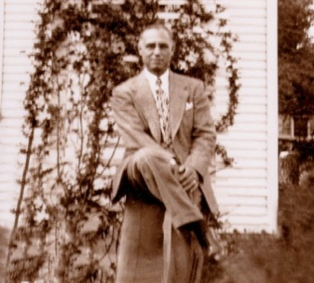
Page 1 Page 2 Page 3 Page 4
September 1st 2026 The Alletto Family Chronicle Page 2 #211111111111111111111111111111111111111111111111111111
Onofrio Alletto

Last names in the Alletto Bloodline

Alletto
Appio
Andon
Bleakley
Bennett
Browoleit
Calvacca
Camacho
DeDona
Dennis
Dumont
Fahey
Fitzsimmons
Gentiluomo
Gonzalez
Giulitto
Hentze
Heijer
Hernandez
Hilton
Hotz
Kravit
Loglisci
Lorimer
Madison

Maher
Marullo
Masucci
Mau
Maurer
McCullough
McElveen
Meloy
Miranda
Monahan
Nohilly
Plastino
Rollman
Salerno
Schwartz
Shutovich
Sullivan
Szczygiel
Traylor
Trocchiano
Vynalek
Weston
Yasenchak
Young

September 1st 2026 The Alletto Family Chronicle Page 2 #211111111111111111111111111111111111111111111111111111
Page 1 Page 2 Page 3 Page 4
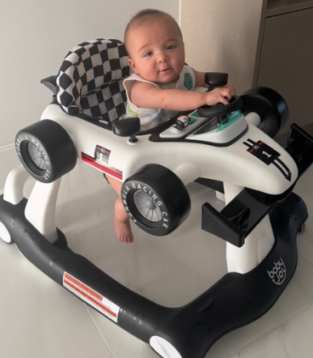
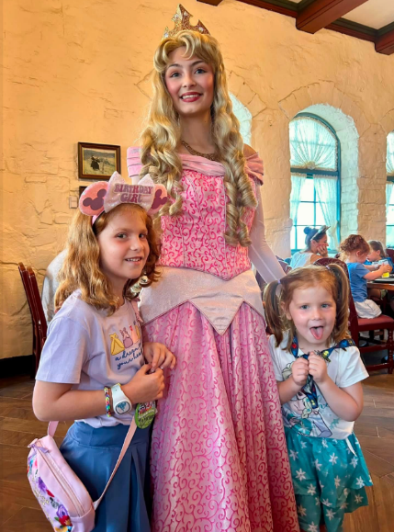
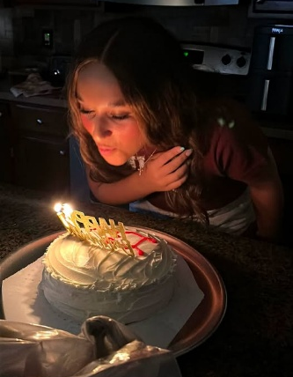
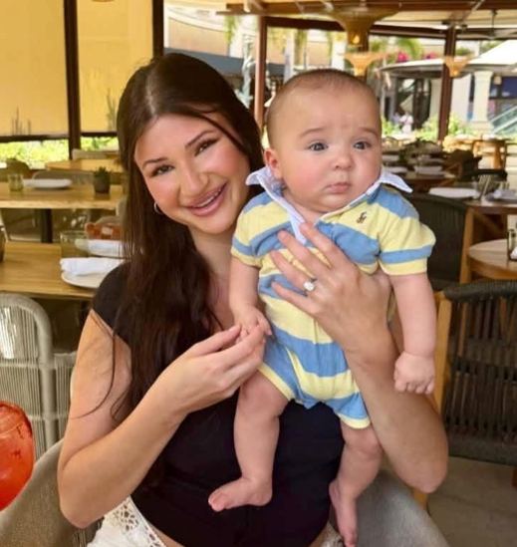
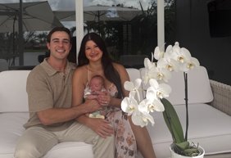
Family Photo
Happy 14th Birthday, Cousin Olivia Schwartz

Riley and Charlie DeDona enjoying a few days at

Page 1 Page 2 Page 3 Page 4
September 1st 2026 The Alletto Family Chronicle Page 3 3#311111111111111111111111111111111111111111111111111111
Page 1 Page 2 Page 3 Page 4

Happy Birthday
Guess Who
Cousins Lisa (Shutovich) Gonzalez and Raul Gonzalez, report: we have become grandparents Our daughter Eva and Hubby Jason Browoleit welcomed their 1st baby blessing, Dominic Ernesto on February 17, 2026. He is a cutie. Our Alletto Family is growing.

Eva, Jason & Dominic
WELCOME

September 1st 2026 The Alletto Family Chronicle Page 3 3#311111111111111111111111111111111111111111111111111111

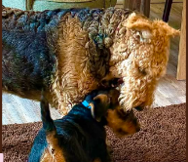
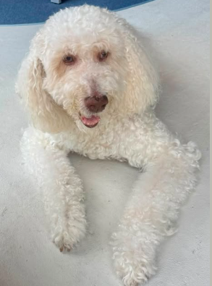
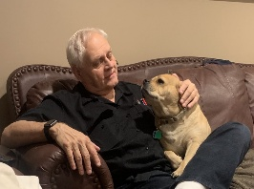

W e L o v e O u r F a m i l y P e t s
September 1st 2026 The Alletto Family Chronicle Page 4 3#411111111111111111111111111111111111111111111111111111
Page 1 Page 2 Page 3 Page 4
Emily Giulitto 9/3
Melissa Alletto 9/4
Carly Maurer 9/6
Gabriella Alletto 9/7
Nancy Hagan 9/7
Amanda Marullo 9/7
Joey Carbone 9/10
SJ Miranda 9/10
Aidan McCullough 9/13
Ronnie Alletto 9/13
Joey DeDona 9/14
Isabella Mau 9/14
*Deceased

September 1st 2026 The Alletto Family Chronicle Page 4 4#411111111111111111111111111111111111111111111111111111
Page 1 Page 2 Page 3 Page 4
Page 1 Page 2 Page 3 Page 4
August 15th 2026 The Alletto Family Chronicle Page #411111111111111111111111111111111111111111111111111111
Page 1 Page 2 Page 3 Page 4
August 15th 2026 The Alletto Family Chronicle Page #411111111111111111111111111111111111111111111111111111
Page 1 Page 2 Page 3 Page 4
August 15th 2026 The Alletto Family Chronicle Page #411111111111111111111111111111111111111111111111111111
Page 1 Page 2 Page 3 Page 4
August 15th 2026 The Alletto Family Chronicle Page #411111111111111111111111111111111111111111111111111111

